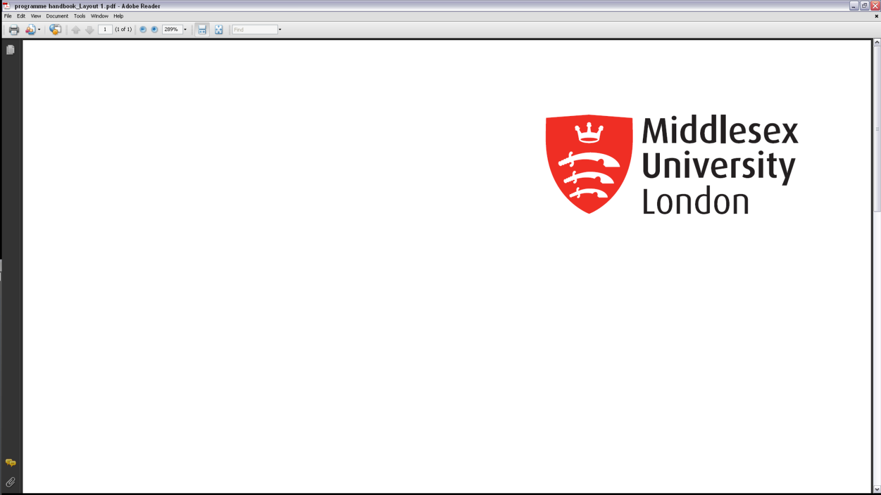

**Middlesex University**

**Academic Quality Service**

**Addition of existing collaborative programme at existing collaborative site proposal form**

|  |  |  |  |  |  |  |  |
| --- | --- | --- | --- | --- | --- | --- | --- |
| **MDX Faculty** | Arts and Creative Industries  Business and Law  Health, Social Care and Education  Science and Technology | | | | | | |
| **Partner Name** |  | | | | | | |
| **Full Address of existing site** |  | | | | | | |
| **Additional existing programme title to be run** |  | | | | | | |
| **Type of collaborative programme** | **Please tick box as appropriate** | | | | | | |
| **Validated** |  | **Franchised** |  | **Joint** | |  |
| **Existing programme(s) currently running at the existing site (all named entry awards)** | **Programme** | | | **ULT** | | **ILT** | |
|  | | |  | |  | |
|  | | |  | |  | |
|  | | |  | |  | |

|  |  |
| --- | --- |
| **Rationale why the programme(s) is/are being proposed to run at this existing site, including target audience.** | |
|  | |
| **Resources** | |
| Are any additional resources required at the Partner? |  |
| Are any additional resources required from MDX for Link tutorship or language of tuition? |  |
| Will a new External Examiner be required? |  |
| For UK partnerships, are there plans to recruit international (non-EEA) students? | Yes  No |

|  |  |  |  |
| --- | --- | --- | --- |
| **Target numbers for this/these programme(s) at this site**  Insert ***Target*** Student numbers for next ***6 years for each programme*** on the site | | | |
| **Programme title** | **Year** | **Student numbers - FT** | **Student numbers - PT** |
|  |  |  |
|  |  |  |
|  |  |  |
|  |  |  |
|  |  |  |
|  |  |  |
| **Programme title** | **Year** | **Student numbers - FT** | **Student numbers - PT** |
|  |  |  |
|  |  |  |
|  |  |  |
|  |  |  |
|  |  |  |
|  |  |  |

|  |  |  |
| --- | --- | --- |
| **Other programme information** | | |
| Please provide full name of PSRB if appropriate |  | |
| Language of tuition |  | |
| Language of assessment |  | |
| In-country approval required | Yes  No | |
| Other existing site(s) where partner runs this programme(s) | Programme | Site |
|  |  |
|  |  |
|  |  |
|  |  |
|  |  |

|  |  |
| --- | --- |
| **Date of approval by Faculty Quality committee** |  |

|  |  |  |  |
| --- | --- | --- | --- |
| **SIGNATURES – joint and franchised programmes** | | |  |
| **Title** | **Name** | **Signature** | **Date** |
| **Library Liaison Manager** *(only required if additional resources e.g. licenses requested)* |  |  |  |
| **Head of CCSS** *(only required if additional software/hardware/support requested)* |  |  |  |