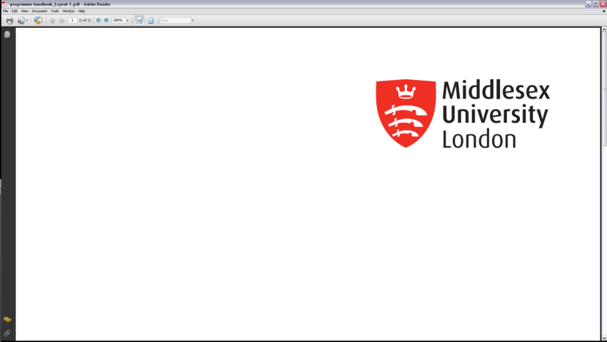 **Middlesex University**

**Academic Quality Service**

**Partnership site closure form**

**(For use when an entire site is closing)**

|  |  |  |  |  |  |  |  |
| --- | --- | --- | --- | --- | --- | --- | --- |
| **MDX Faculty** | | Arts and Creative Industries  Business and Law  Health, Social Care and Education  Science and Technology | | | | | |
| **Partner Name** | |  | | | | | |
| **Full postal address of site to be closed** | |  | | | | | |
| **Type of collaborative programme (s)** | | **Please tick box as appropriate** | | | | | |
| **Validated** |  | **Franchised** |  | **Joint** |  |
| **ULT** | |  | | | | | |
| **ILT** | |  | | | | | |
| **Programmes affected by closure** | | | | | | | |
| **Programme code** | **Programme title** | | | | **Date of last recruitment** | | |
|  |  | | | |  | | |
|  |  | | | |  | | |
|  |  | | | |  | | |
| **Does this programme(s) run at any other sites?**  **\*If so, which one(s)?** | | Yes*  No | | | | | |
| **Rationale for closure** | | | | | | | |
|  | | | | | | | |

|  |
| --- |
| **Phasing out/transfer arrangements, including a phasing out schedule for each programme at that site. Please include information about any relevant Articulation Agreement(s) if appropriate.** |
|  |

|  |  |
| --- | --- |
| **Proposer to confirm that all affected students were consulted and agreed. This includes consideration of the University’s Student Protection Plan.** | Yes  No  N/A |

|  |  |  |
| --- | --- | --- |
| **Suggested alternative programme and/or site for applicants** | | |
| **Programme code** | **Programme Title** | **Site** |
|  |  |  |
|  |  |  |
| ***For in-house/Joint/***  ***Franchised programmes only.***  **Summary of communication plan for current enquirers/**  **applicants/offers (recruitment relationships team to agree and execute)** |  | |
| ***For Joint/Franchised/***  ***Validated programmes only.***  **Summary of plan for updating the Middlesex collaborative partner web page and partner website** |  | |

|  |  |
| --- | --- |
| **Faculty Quality committee approval date** |  |