**Guidance for Hosting Online / Virtual Meetings**

There may be times where you may need to host your Programme Voice Group online or in a virtual capacity. This is common practice for those courses with distance learning or where students may be on placement.

This guide aims to help advise on the process, and provide some ideas for how you can host your meeting.

**Setting the Agenda (PVG Agenda Setting Meeting)**

You should offer students to shape the agenda, as you would with an in-person meeting. This can be done either by asking your Student Voice Leaders (SVLs) to email in their feedback (both positive and suggestions for improvement) to the Administrator, or through a feedback form or small survey.

Depending on the size of the programmes and number of SVLs you have, you can choose whether you send this out to all students or just the SVLs. You could even ask them to each identify their top 3 concerns from the feedback they will be giving, in order to ensure the big items are discussed (particularly in the bigger meetings), and to note the other items. It is important to collect their demographic information, i.e. which year and programme they are a part of, as this will make the recording of minutes and issues easier.

The Agenda will follow the same template as per the Learning and Quality Enhancement Handbook.

**Meeting Etiquette**

In order to ensure you have a successful meeting, here are some points to help your meeting run smoothly and as accessible as possible. These can be achieved via the main platforms described in this guide:

* **Staff can display titles within their names,** to enable students to understand their role (e.g. Chair, Officer, HoD, DoP) or the service they are representing at the meeting (LSS, CCSS etc).
* **All participants should be encouraged to ensure their names are displayed** at the start of the meeting for the purposes of recording attendees accurately in the minutes.
* **All participants (except the Chair/the person leading the item) should be muted once the meeting starts**. The Chair can welcome those who wish to speak to be unmuted.
* **If participants wish to speak or ask questions**, they can use the chat function or ‘raise their hand’ feature to indicate to the Chair or speaker that they wish to contribute. After they have asked their question, participants should be reminded to ‘lower their hand’.
* **When asking questions**, be prepared to leave a longer than natural pause – to allow for participants to unmute themselves, find their microphones, etc.
* **Cameras**. As Broadband and internet connection strength can vary, it is suggested that cameras can be turned on at the start for participants to see each other and for introductions of those present, but then it is recommended that participants turn off their cameras in order to lower bandwidth usage. Camera usage should be considered optional at all times.
* **Backgrounds.** Chairs and Officers can encourage participants to use a neutral background or effect, for privacy.
* **Pronouns.** Chairs and Officers can encourage participants to show their preferred pronouns within their ‘display name’, e.g. *‘Hendon Barnet’ (He/Him/His)*, to aid with ensuring the correct pronouns for participants are being used. Other examples would be *(She/Her/Hers)* or *(They/Them/Theirs)*.
* **Accessibility.** When inviting participants to the meeting, Officers should ask if any participants have accessibility needs and work with the Chair and CAPE to ensure that these can be catered for. Additionally, in order to make the meeting more accessible and support those whose first language is not English, Chairs should make participants aware if they are able to turn on subtitles for the meeting.
* **Recording the meeting.** Programme Voice Group minutes are made public to the Programme, therefore, in order to aid the Officer in producing minutes, meetings can be recorded. Participants should be made aware that the recording would only be accessed by the Servicing Officer for the purpose of recording accurate minutes and would be destroyed afterwards.
* **Screen sharing the main documents.** If possible, it would be beneficial for Officers to screen share the agenda, minutes, action plan and main documents for the meeting, to help with running the meeting and for late arrivals to join in.
* **Breaks.** It is important to schedule a 5 minute comfort break after 45minutes or at an appropriate interval in business (depending on the length of the meeting).

**Running the Meeting**

There are several ways you can run the meeting:

* **Zoom**

Zoom is available for all Middlesex Staff and Students to access through their University accounts. You can login with your University credentials using the following URL <https://mdx-ac-uk.zoom.us/>

Zoom allows screen sharing of documents, provides a chat-bar and breakout rooms – which can be useful when hosting a larger Programme Voice Group as it can enable smaller group discussions to then feed into the main meeting. Additionally, there is the option to run polls to gather student feedback on items, or to conduct votes.

Zoom enables you to host large live meetings, and can provide recordings (either audio or visual) that can be accessed by the Officer for the purpose of writing minutes. It will additionally allow you to access a full list of participants, and a copy of the meeting’s chat. Students will be used to Zoom through it being part of their learning delivery.

Zoom provides the option for participants to change their backgrounds and has accessibility features such as the provision of enabling subtitles.

CAPE has produced a guide to Zoom, including detailed instructions on setting up meetings and how to record attendance of participants, which can be accessed here: <https://www.intra.mdx.ac.uk/about-us/services/centre-for-academic-practice-enhancement/technology-enhanced-learning/tel-tools/zoom>

* **Microsoft Teams**

Microsoft Teams has been rolled out to Middlesex Staff and Students to be able to collaborate together, hold virtual meetings and work on documents. The full Teams package that is available to Staff is currently being rolled out to students through a phased plan during the academic year, but presently students are able to use their account as connected through their Middlesex email address and thus attend meetings that they are invited to.

Teams shares much of the same functions as Zoom, including the sharing of documents, chat-bar to hold discussions, ability for participants to change their backgrounds, enabling of subtitles and provides recordings of meetings (the recordings will be made available to the organiser of the meeting, via OneDrive and a folder called ‘Recordings’). Students will be used to Teams as it is incorporated into their learning delivery.

CAPE has produced a guide to Microsoft Teams, which can be accessed here: <https://www.intra.mdx.ac.uk/about-us/services/centre-for-academic-practice-enhancement/technology-enhanced-learning/tel-tools/microsoft-teams>

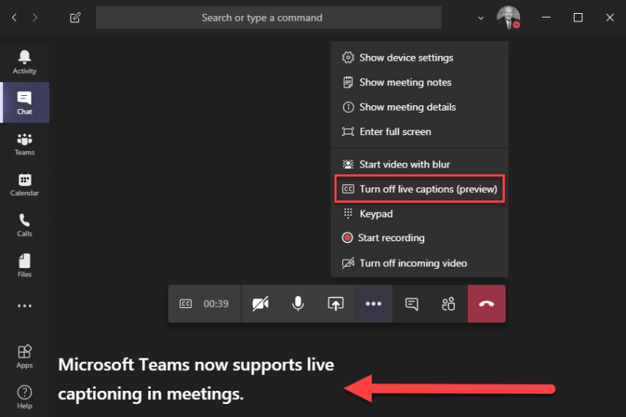

*How to enable Subtitles*

* **Kaltura NewRow**

Kaltura NewRow (also known as a ‘Kaltura Virtual Classroom’) is virtual classroom software and a way to conduct small to large meetings. Much like Zoom and Microsoft Teams, it is quite easy to use and students will be familiar with the software through the learning delivery.

Kaltura NewRow can offer break-out rooms, which is beneficial for larger Programme Voice Groups to host smaller discussions. There is a chat-bar, the ability to raise your hand, share screens and to customise backgrounds. Meetings can also be recorded. The host of the meeting can choose who to have as ‘presenters’, which gives them access to share screens, have videos on and respond to questions.

CAPE has produced a guide for Kaltura NewRow which is available via MyLearning here: <https://mdx.mrooms.net/mod/book/view.php?id=1206504>

* **My Learning: Forums**

You can run your meetings through a ‘Forum’ on the Programme’s page on MyLearning. On this platform students can choose to give feedback anonymously if they choose.

You may already have this section enabled – if not, this is the way we recommend to set it up:

1. Go to My Learning and access the correct course (i.e. the Programme page where all students are subscribed).

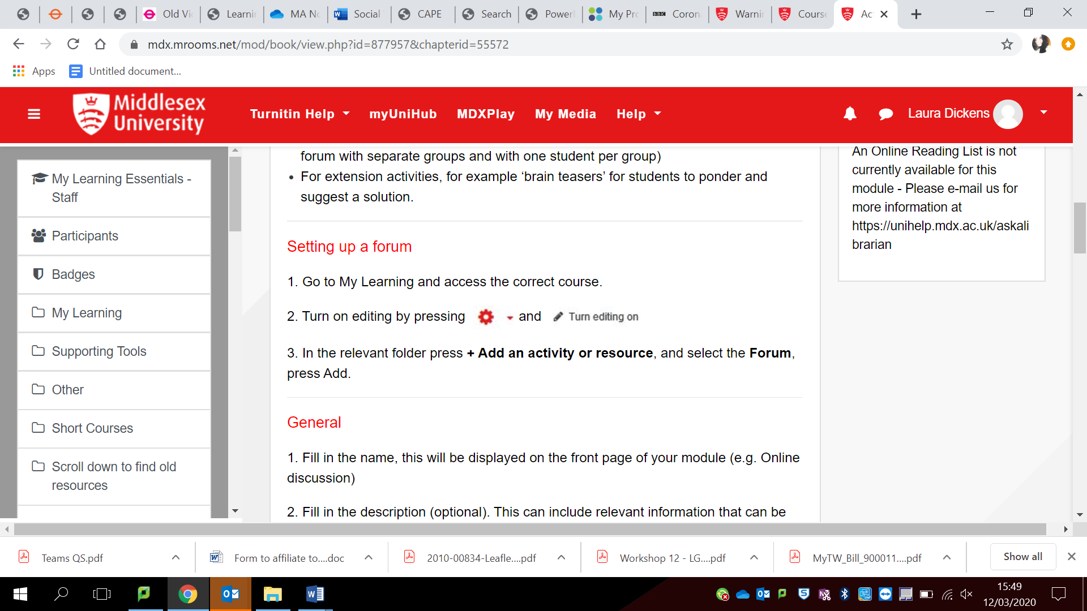2. Turn on editing by pressing and select ‘*Turn editing on*’

3. Create a new folder called “*Programme Voice Group*” (if you do not already have a folder dedicated to Programme Voice Groups).

4. In the relevant folder press + *Add an activity or resource*, and select the *Forum*, press Add.

5. Name your Forum (we recommend Programme Voice Group – plus the date, e.g. *MA Transport Systems 24 January 2022*)*.* This will be displayed on the front page and must be easy and obvious for students to find.

6. Fill in the description (optional). This can include relevant information – e.g. an encouragement for feedback.

7. Select the forum type. There are five forum types for different purposes. Here we recommend you either use a ‘*Standard Forum for General Use*’.

8. In the settings for the Forum, you can choose who can participate in terms of Subscriptions.

If you would like **all students** to participate in the Forum, then you can select *‘Auto-Subscription’* (this will automatically subscribe all students on the Programme to the Forum, where they will be able to post discussions and reply).

If you would like **just your SVLs** to participate, you can select ‘*Optional Subscription*’ and then send your SVLs a link to the Forum. This means that they can subscribe themselves to the discussions and then start to participate.

9. You can upload relevant papers for the meeting to the Section, i.e. previous meeting minutes, agenda, papers from Service departments.

Here is an example for what the Forum can look like:

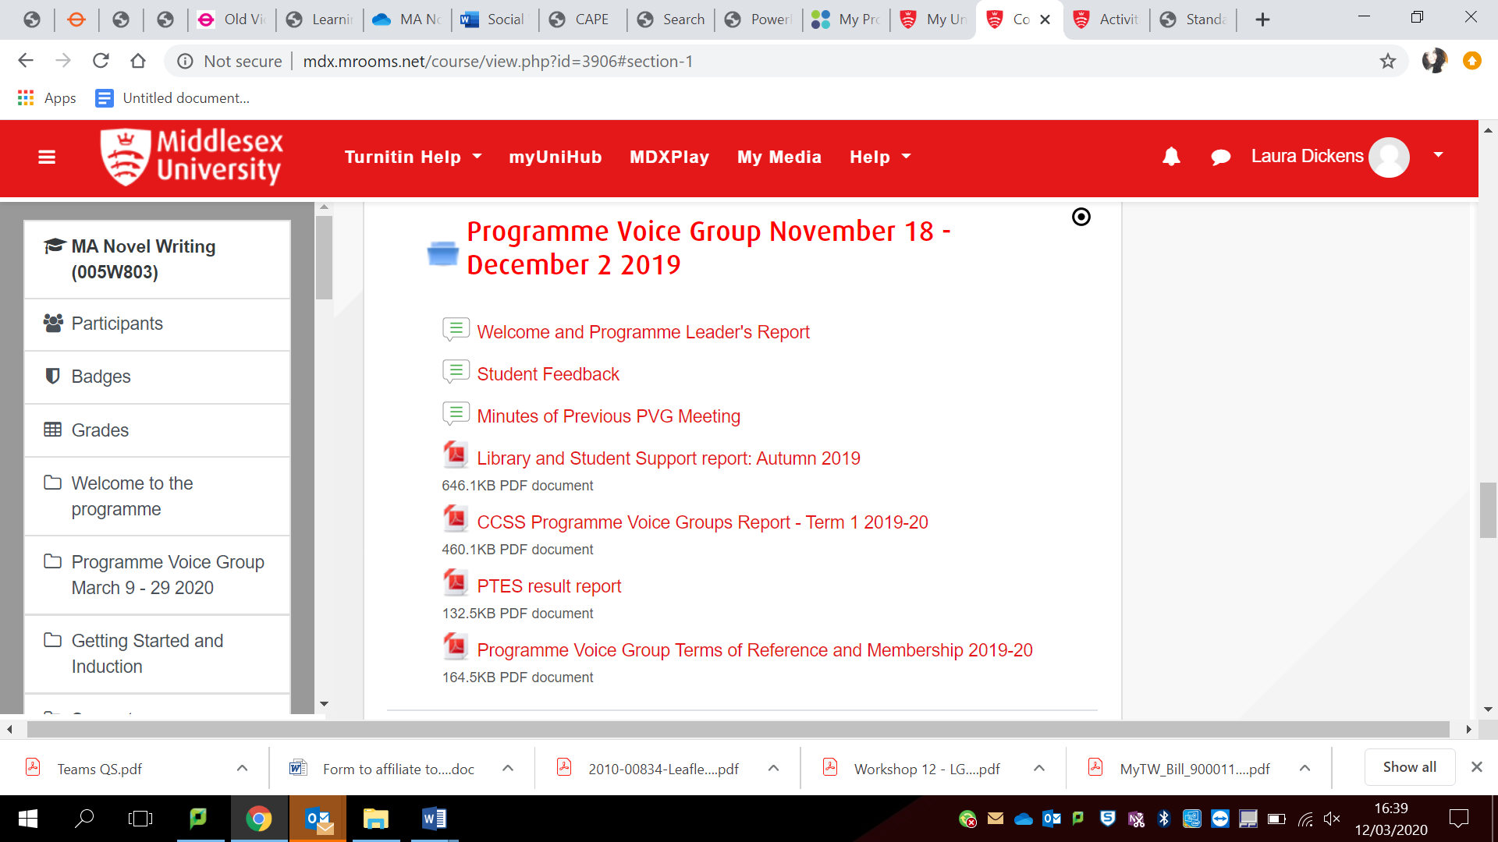

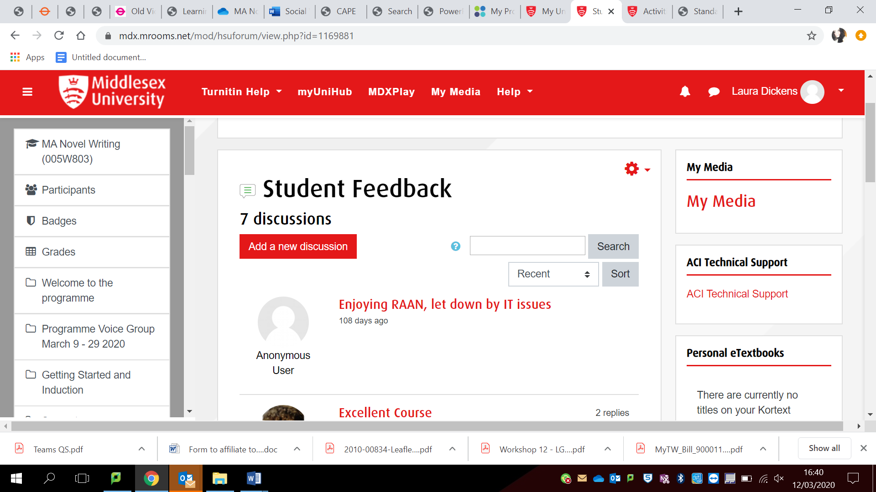

Further guidance is available in the [Moodle Essentials – Staff - Forums](https://mdx.mrooms.net/mod/book/view.php?id=877957&chapterid=55572) page on MyLearning.

**These are just some of the options of ways you can host a virtual meeting. We are aware that this is a constantly developing area so we will endeavour to update guidance accordingly.**

**If you do not feel comfortable hosting via any of these options, the minimum we require is for you to collect e-mail feedback from SVLs and to write this out in the minutes and respond to it.**

**If you need any support setting up your meetings, please contact pvgs@mdx.ac.uk**

**Minutes**

The minutes template for virtual meetings is the same as the usual template used, and actions and responses should still be recorded and shared with students within the same timeframes.

**Recording Attendees**

All those who engage with the online meeting, or who have provided feedback, should be listed as attendees, by listing their name, followed by their role *e.g. Adam Smith, Economics Year 1 SVL,* where they are specifically SVLs*.*

If you have a meeting open to all Students or where the attendance is unknown (e.g. on a MyLearning Forum), please count the number of Students who have participated.

It is important to have a list of Student Attendees and Staff Attendees. This helps us when we come to analyse the number of students and staff attending meetings overall. Ensure to identify the Chair and the Officer (Secretary) of the meeting.

**Closing the Feedback Loop**

Minutes should state where actions have been completed. There are respective columns for actions and deadlines on the templates.

As the meeting is being held virtually, you could circulate the issues to the relevant staff and services in order to provide a response before the minutes are uploaded and circulated to students.

**Circulation**

Minutes should be uploaded to the relevant MyLearning space where all students on the Programme can access them, and copies sent through to [pvgs@mdx.ac.uk](mailto:aqsengagement@mdx.ac.uk)

**Further Advice**

If you need any help with conducting your online or virtual meetings, please contact [pvgs@mdx.ac.uk](mailto:aqsengagement@mdx.ac.uk) or visit the links provided.