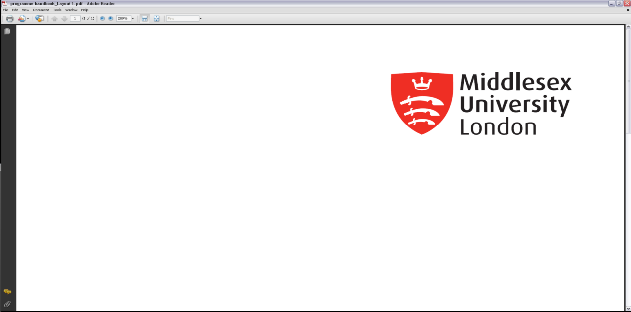***Draft Agenda***

**[Name of Faculty]**

**[Programme(s) name] Programme Voice Group**

**Meeting held on [date and time] at [campus] in [room]/[online platform, e.g. Teams, Zoom]**

|  |  |  |  |
| --- | --- | --- | --- |
| **AGENDA Semester/Year** | | | |
| **Part 1 – Preliminary Items/Introduction** | | **Paper** | **Led By** |
|  |  |  |  |
| 1.1 | Welcome, Introduction, and Apologies | Verbal | Chair |
|  | *Including brief overview of Terms of Reference and Membership.* |  |  |
|  |  |  |  |
| 1.2 | Minutes of the Previous Meeting  *To confirm for accuracy. Actions covered in next item.* | Paper No. | Chair |
|  |  |  |  |
| **Part 2 – Programme Feedback** | | **Paper** | **Led By** |
|  |  |  |  |
| 2.1 | Update and Discussion of Outstanding Actions from the Previous Minutes | Paper No. | Chair |
|  |  |  |  |
| 2.2  2.3 | Student Feedback  *Begin with items of feedback that students have raised prior to the meeting (provide these as a list if possible), and any feedback that the programme team want to discuss.*  *Details of programme or module developments and changes should be discussed here.*  *It is suggested that Welcome week/ induction is added as an item.*  *If possible, look to separate the* ***positives*** *(praise) and* ***suggestions for improvement*** *that are raised. e.g.*  *2.5.1. Welcome Week*  *2.5.2. Module M123456 – Online Materials*  *Feedback on Apprenticeship/Foundation Year/Distance Education version of programmes to be made explicit, as appropriate*  Programme Leaders’/DoP Update  *Updates on areas not previously discussed above and any initial responses to feedback* | Verbal/Paper  Verbal/Paper | SVLs/Staff  Staff |
|  |  |  |  |
| 2.4 | Student survey actions and External Examiner reports | Verbal/Paper | Staff |
|  | *Updates on themes from and actions planned or taken in response to NSS/PTES/Module surveys (as appropriate). A short summary of External Examiner reports. The full reports will have been made available to students prior to the meeting.* |  |  |
|  |  |  |  |
|  | *The following items to be covered for apprenticeship programmes only:*  *Onboarding; off-the-job training, Tripartite Progress Review, employer feedback (as appropriate).* |  |  |
|  |  |  |  |
| **Part 3 – Quality and Student Information** | | **Paper** | **Led By** |
|  |  |  |  |
| 3.1 | To receive updates from *(reports from relevant professional and programme related services such as LSS/CCSS/Technical Staff/Placement Providers/MDXWorks /Finance)* | Paper No. | Staff |
|  |  |  |  |
|  |  |  |  |
|  |  |  |  |
| **Part 4 – Additional Items** | | **Paper** | **Led By** |
|  |  |  |  |
| 4.1 | To note any other business | Paper /  Verbal | SVLs /  Staff |
|  |  |  |  |
| 4.2 | To note the date of the next meeting | Verbal | Chair |