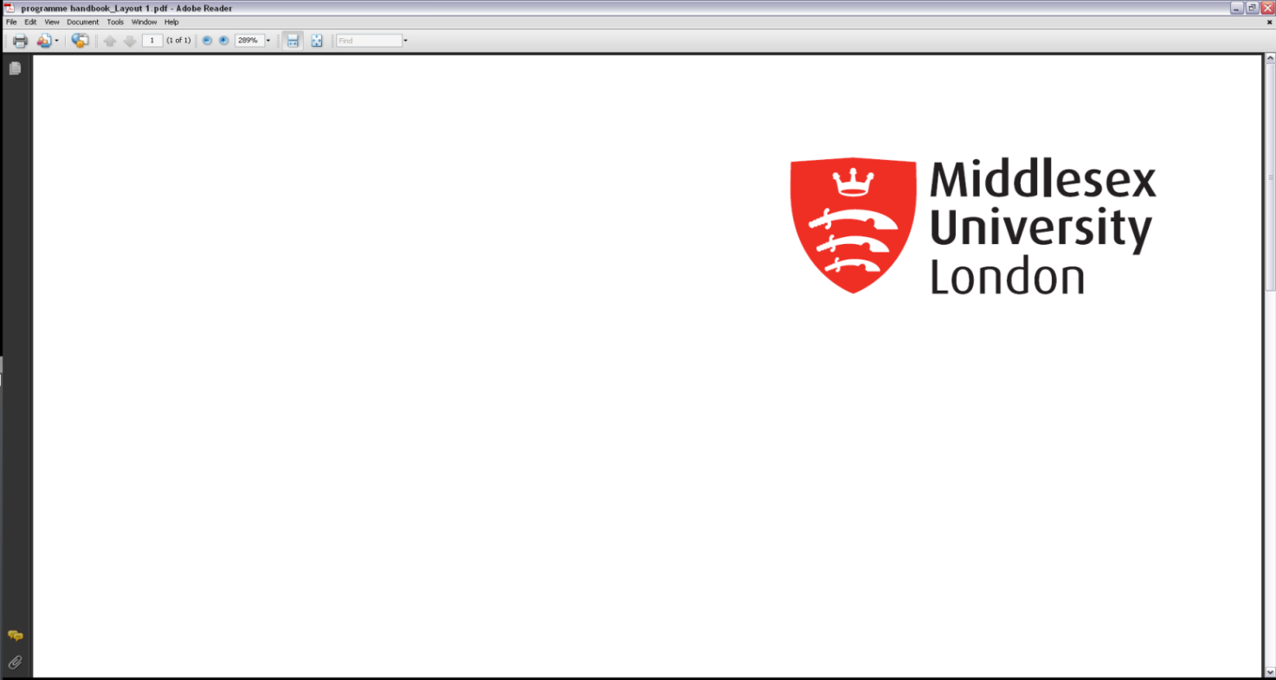*Delete/Update any text in purple

**[Name of Faculty]**

**[Programme(s) name] Programme Voice Group**

**UNCONFIRMED/CONFIRMED minutes and actions from the meeting held on [date] via Zoom/Teams/In Person/Blended/Online**

**Student Members Present**

*\*List all Student Voice Leaders with their name, programme and level.*

**Staff Members Present**

*\*List all staff present with their name and job title. Indicate Chair and Officer in brackets.*

**Apologies**

*\*Please list all apologies received from both staff and students*

**Absent**

*\*Please list all members who were not present and did not sent apologies.*

NB: If you would prefer not to list Absentees, then please email the details of those not present to [pvgs@mdx.ac.uk](mailto:pvgs@mdx.ac.uk) and su[studentvoice@mdx.ac.uk](mailto:studentvoice@mdx.ac.uk) so we can make contact.

**Part 1 – Preliminary items/Introduction**

**1.1 Welcome, Introduction and Apologies**

*Terms of reference and membership will be briefly referred to and students informed where they can find this. (1st meeting only)*

**1.2 Minutes of the previous meeting [paper number]**

*To approve the accuracy of the minutes and note any amendments that need to take place.*

|  |  |  |  |
| --- | --- | --- | --- |
| **Part 2 – Programme Feedback** | | | |
| **Paper Number and Ref** | **Summary of Discussion** | **Action(s) and by Whom and When?** | **Update**  *Indicate if action completed by highlighting.* |
| 2.1 Outstanding Actions from the Previous Minutes | | | |
| *As per previous actions* | *\* Notes in here should actions from the previous minutes that still need addressing, what action has been taken to date and whether further action is required.*  *EXAMPLE* | *\*should include details of actions to be completed.* | *\*what action has been taken to date.* |
| 2.1.1 | *“Microwave in College Building”*  *Year 3 SVLs requested additional microwaves in the College Building.* | *Chair to raise with Estates and Facilities by 10 January 2022.* | *Estates and Facilities have responded that they will conduct a feasibility review for installing additional microwave facilities.*  **COMPLETED 7 JANUARY 2022** |
|  |  |  |  |
| 2.2 Student Feedback | | | |
| *As per agenda*  2.2.1 | *\*Notes in here should include a small summary of the discussion and the key feedback being given. Each block should have a heading from the agenda to highlight the discussion, including module code i.e.*  *“Online Learning Resources”.*  *Year 2 SVLs requested additional access to e-books for module M12345* | *ML for M12345 to raise with LSS by ASAP.* |  |
|  |  |  |  |
| 2.3 Programme Leaders/DoP Update | | | |
| 2.3.1 | *\*Include brief detail of PL and DoP update(s) and whether there are any further actions.* |  |  |
| 2.4 Student survey actions and External Examiner reports | | | |
| 2.4.1 | *\*Provide a small summary of relevant survey actions, and EE reports.* |  |  |
|  |  |  |  |

P

|  |  |  |  |
| --- | --- | --- | --- |
| **Part 3 – Discussion on Quality and Student Information** | | | |
| 3.1 The Group received the following reports. The following discussions and actions were agreed; *(If applicable)* | | | |
| **Paper Number and Ref** | **Summary of Discussion** | **Action(s) and by Whom and When?** | **Update**  *Indicate if action completed by highlighting.* |
| *Service Reports*  3.1.1 | *E.g. CCSS, LSS, Finance, Catering reports*  *Provide a small summary of highlights* |  |  |

art

|  |  |  |  |
| --- | --- | --- | --- |
| **Part 4 – Additional Items** | | | |
|  |  |  |  |
| **4.1** | **Any Other Business** | | |
|  |  | | |
| **4.2** | **Date of Next Meeting** | | |
|  |  | | |
|  |  | | |

Drafted: [date]

Agreed by Chair: [date]

Circulated: [date]

Confirmed: [date]

Date Published on MyLearning pages: [date]