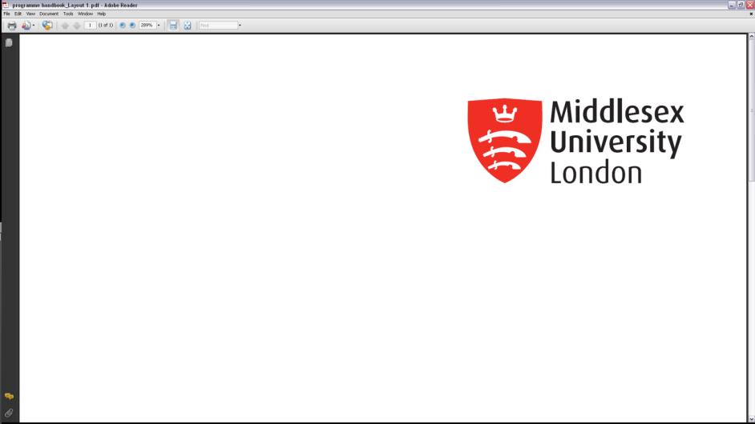

**Academic Quality Service**

**Programme Change Form**

**Requesters must ensure that this form is signed by both the requester and the DoP before being submitted to the Faculty Committee, and that evidence of approval by the relevant External Examiner is also attached. For Apprenticeship programmes, this may require re-submission of the Apprenticeship mapping grid.**

|  |  |
| --- | --- |
| **Programme title(s)** | **Programme code(s)** |
|  |  |
| **Campus(es) where delivered** | |
|  | |
| **Collaborative Partner name (if applicable) (Please also include reference to any relevant Articulation Agreement(s))** | |
|  | |

|  |  |  |
| --- | --- | --- |
| **Type of change**  Please provide full details of the change required together with information about what is current. (If the change could have an impact on the programme specification or module narratives, please attach the existing and proposed programme specification and relevant module narratives to this form, or existing documents with track changes).  If the proposed change is to the English language requirements, this should be considered by the English Language Qualifications Working Group in the first instance, and then submitted to the Faculty Quality Committee for final approval. | | |
|  | | |
| **2031 Learning Framework Programme Adjustments**  (for in-house, franchised and joint programmes only) | | |
| Will the proposed programme fully align with the 2031 Learning Framework Principles? | | Yes  No  If no, please append the completed Programme Adjustment Form |
| **Rationale for change** | | |
|  | | |
| **Date from which the change is to be effective** | | |
| **Academic Year:** |  | |
| **Semester:** |  | |

|  |
| --- |
| **How will current students be affected?**  Clarify whether existing students will phase out on the existing programme or transfer over to a new/modified programme. Please include diagrams if necessary. Please ensure there has been consideration of the University’s Student Protection Plan in your proposal.  Please note that changes can affect applicants who will need to be informed by the Admissions Team. |
|  |

|  |  |  |
| --- | --- | --- |
| **Module closures**  *Please list any modules to be closed as a result of this change* | | |
| 1. Existing Modules to be deleted from ***this programme only*** | | |
| Module code | Module title | Last run e.g. 202410 |
|  |  |  |
| 1. Existing Modules to be deleted from ***the module stock entirely*** | | |
| Module code | Module title | Last run e.g. 202410 |
|  |  |  |

|  |  |
| --- | --- |
| **Proposer to confirm all staff at partners/campus(es) were consulted and agreed to the change** | Yes  N/A |
| **Proposer to confirm that all affected students were consulted and agreed to the change (including franchised and campus students) in line with APS28 and Guidance 3xxvi Making changes to published information:** [Learning and Quality Enhancement Handbook (LQEH)](https://eur02.safelinks.protection.outlook.com/?url=https%3A%2F%2Fwww.mdx.ac.uk%2Fabout-us%2Fpolicies%2Facademic-quality%2Fhandbook&data=05%7C01%7CS.Wellstead%40mdx.ac.uk%7C35eeb3e5120c42c1ccb608db4257d902%7C38e37b88a3a148cf9f056537427fed24%7C0%7C0%7C638176717302698097%7CUnknown%7CTWFpbGZsb3d8eyJWIjoiMC4wLjAwMDAiLCJQIjoiV2luMzIiLCJBTiI6Ik1haWwiLCJXVCI6Mn0%3D%7C3000%7C%7C%7C&sdata=ossiw6RN1G5gPXm6%2BSo5S%2BR02v1lgXoym6zTe3RnfL8%3D&reserved=0) | Yes  N/A |
| **Proposer to confirm the External Examiner(s) were consulted and agreed to the change (please attach evidence of approval)**  *(Confirm requirements with AQS)* | Yes  N/A |
| **For Apprenticeship programmes, proposer to confirm all employers were consulted** | Yes  N/A |

In considering making a change to an existing programme, please consult Section 3.7 of the Learning and Quality Enhancement Handbook (LQEH)

|  |  |
| --- | --- |
| **Requested by:** |  |
| **Date:** |  |

|  |  |  |
| --- | --- | --- |
| **Date approved by University Link Tutor (if applicable)** | **Name** | **Signature** |
|  |  |  |
| **Date approved by Director of Programmes** | **Name** | **Signature** |
|  |  |  |
| **Date approved by Head of Department** | **Name** | **Signature** |
|  |  |  |
| **Date approved by Chair of Faculty Committee** | **Name** | **Signature** |
|  |  |  |

|  |  |
| --- | --- |
| **Faculty Committee Quality Enhancement Officer to confirm whether Major or Minor Change** | Major  Minor |

**The Committee Officer should circulate the signed form (and programme specification if appropriate) as per the Communications Process**