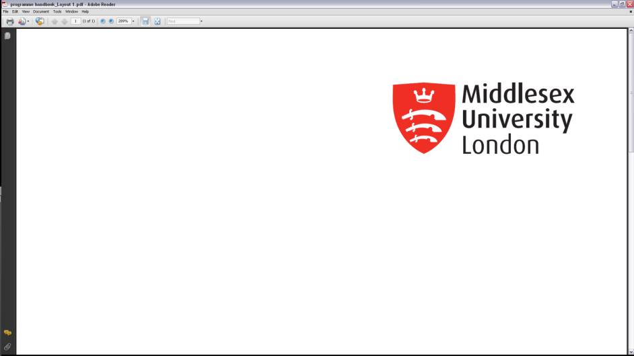

**Academic Quality Service**

**Module Change Form**

|  |  |
| --- | --- |
| **Module Code:** |  |
| **Module Title:** |  |
| **Module Leader:** |  |

|  |  |  |
| --- | --- | --- |
| **Programme(s) using this module** | | |
| Programme code(s) | Programme title(s) | Core/optional |
|  |  |  |
|  |  |  |
| **Collaborative Partner name/Campus(es) (if applicable)** | | |
|  | | |

|  |  |
| --- | --- |
| **Type of Change** | **Please check if being requested** |
| Module Title* (this will require a new module code) |  |
| Aims* |  |
| Syllabus* |  |
| Learning Outcomes* |  |
| Learning and Teaching Strategy* |  |
| Module Delivery Method* |  |
| Formative Assessment Scheme* |  |
| Summative Assessment Scheme* |  |
| Deletion of module |  |
| Addition or Change of Module Run |  |
| Other (please specify) |  |

*Changes marked with an asterisk must be agreed by the relevant current External Examiner (including levels 3 and 4); please ensure that you include evidence of this approval before sending the form to the Faculty Quality Committee.

**All changes must be agreed by all affected students. Please note that changes can affect applicants who will need to be informed by the Admissions Team.**

|  |  |  |  |
| --- | --- | --- | --- |
| **Date from which the change is to be effective** | | | |
|  | | |  |
|  | | |  |
| **Detail of change required**  Please provide full details of the change required together with information about what is current. | | | |
|  | | | |
| **2031 Learning Framework Programme Adjustments**  (for in-house, franchised and joint programmes only) | | | |
| Will the proposed programme fully align with the 2031 Learning Framework Principles? | | Yes  No  If no, please append the completed Programme Adjustment Form | |
| **Are Programme Learning Outcomes significantly affected?** | Yes  No    **If Yes, this will be considered a major change, and will require programme review** | | |
| **Do these changes impact on the published programme specification?** | Yes  No  **If Yes, you must attach a Programme Change Form and current and proposed programme specification(s) or existing programme specification with track changes** | | |
| **Rationale for change** | | | |
|  | | | |

|  |  |
| --- | --- |
| **If module delivery is changing (e.g. fully or partially online), proposer to confirm CAPE Business Partner has been consulted regarding adjustments needed to support students.**  **CAPE BP Link:** [**https://www.intra.mdx.ac.uk/about-us/services/centre-for-academic-practice-enhancement/about-cape**](https://www.intra.mdx.ac.uk/about-us/services/centre-for-academic-practice-enhancement/about-cape) **(requires intranet login)** | Yes  N/A |
| **Proposer to confirm that all affected students were consulted and agreed to the change (including franchised and campus students) in line with APS28 and LQEH Guidance 3xxvi:**  [**Learning and Quality Enhancement Handbook (LQEH) | Middlesex University London (mdx.ac.uk)**](https://www.mdx.ac.uk/about-us/policies/academic-quality/handbook) | Yes  N/A |
| **Proposer to confirm all partners/campus(es) were consulted and agreed to the change** | Yes  N/A |
| **Proposer to confirm the External Examiner(s) were consulted and agreed to the change (please attach evidence of approval)**  *(Confirm requirements with AQS)* | Yes  N/A |
| **For Apprenticeship programmes, proposer to confirm all employers were consulted** | Yes  N/A |

|  |  |
| --- | --- |
| **Requested by:** |  |
| **Date:** |  |

**Requesters must attach a copy of the current and proposed Module Narratives (or with tracked/highlighted changes) and ensure that this form is signed by both the requester, the University Link Tutor (if applicable), DoP and the HoD before being submitted to the Faculty Committee.**

In considering making a change to an existing module, please consult Sections 3.7 and 3.8 of the Learning and Quality Enhancement Handbook (LQEH).

|  |  |  |
| --- | --- | --- |
| **Date approved by University Link Tutor (if applicable)** | **Name** | **Signature** |
|  |  |  |
| **Date approved by Director of Programmes** | **Name** | **Signature** |
|  |  |  |
| **Date approved by Head of Department** | **Name** | **Signature** |
|  |  |  |
| **Date approved by Chair of Faculty Committee** | **Name** | **Signature** |
|  |  |  |

|  |  |
| --- | --- |
| **Faculty Committee to confirm whether Major or Minor Change** | Major  Minor |

**The Committee Officer should circulate the signed form (and programme specification/module narratives if appropriate) as per the Communications Process**